Skupovi oko nas

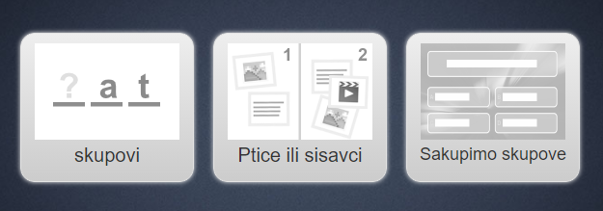

https://learningapps.org/display?v=ptxij0c4520

Autorica: Renata Svedrec, OŠ Otok, Zagreb

