Brojevi

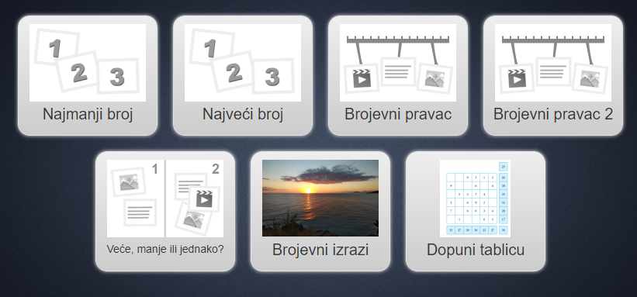

https://learningapps.org/display?v=pj4wkcria20

Autorica: Renata Svedrec, OŠ Otok, Zagreb

